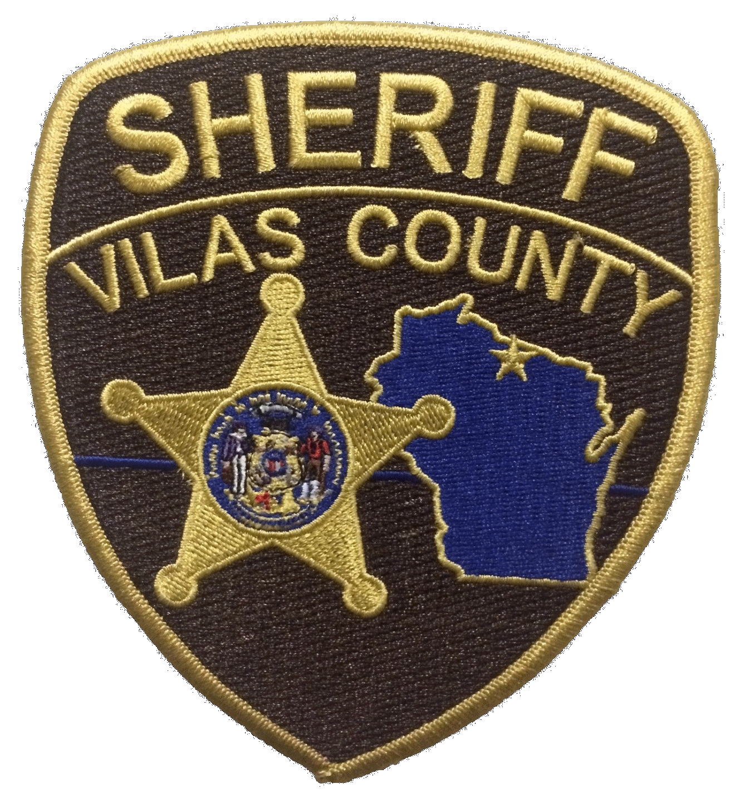 |  | VILAS COUNTY
 |  | SHERIFF’S OFFICE
330 Court Street, Justice Center
Eagle River, WI 54521-8362
Patrick Schmidt , Chief Deputy  Gerard Ritter, Captain  William Weiss, Jail Admin |  | Joseph A. Fath  Sheriff  www.vilascountywi.gov |  | Tele: 715 479-4441  Fax: 715 479-6039

Vilas County Jail (2020) Annual PREA Report

The Prison Rape Elimination Act (PREA) is a federal law that was established in 2003 and applies to all correctional facilities and jails. In 2017, Vilas County began to focus on PREA requirements and the need to eliminate, reduce, and prevent sexual assault, abuse, and harassment in all correctional facilities.

Vilas County makes every reasonable effort to comply with the Prison Rape Elimination Act (PREA) and all such misconduct shall be investigated immediately to determine the nature of the allegation and the appropriate action to be taken.

In an effort to protect the inmates of the Vilas County Jail from sexual misconduct, there shall be no sexual activity between staff and inmates, nor between inmate and inmate.

Vilas County has a Zero Tolerance policy pertaining to all sexual misconduct, including sexual abuse and harassment. We are working continuously to implement new policies and procedures, including PREA training requirements for staff and inmates, developing standards for detection, prevention, and reduction of sexual misconduct. It is our goal to ensure that all sexual misconduct is reported and investigated accurately and completely.

It is the policy of the Vilas County Jail to respond and thoroughly investigate every allegation of sexual misconduct reported, and to do it in a timely manner. All cases will have a determination of:

Substantiated Allegation: This means a sexual assault/abuse allegation was investigated and determined to have occurred.

Unsubstantiated Allegation: This means a sexual assault/abuse allegation was investigated and the investigation produced insufficient evidence to make a final determination as to whether or not the event occurred.

Unfounded Allegation-Discipline Issue: This means a sexual assault/abuse allegation was investigated and determined not to have occurred, however, discipline was issued due to sexual harassment.

Unfounded Allegation: This means an allegation was investigated and determined not to have occurred.

 | Substantiated | Unsubstantiated | Unfounded Discipline | Unfounded | Ongoing Investigation | Total Reported
Inmate/Inmate PREA Violation | 0 | 0 | 2 | 2 | 0 | 2
Inmate/Staff PREA Violation | 0 | 0 | 0 | 0 | 0 | 0

 |  | VILAS COUNTY
 |  | SHERIFF’S OFFICE
330 Court Street, Justice Center
Eagle River, WI 54521-8362
Patrick Schmidt , Chief Deputy  Gerard Ritter, Captain  William Weiss, Jail Admin |  | Joseph A. Fath  Sheriff  www.vilascountywi.gov |  | Tele: 715 479-4441  Fax: 715 479-6039

PREA Teams
In an effort to be more effective in the implementation, education, and monitoring of the PREA program, the Vilas County Jail has developed two teams who provide guidance, oversight, and review of all PREA incidents and assist staff with PREA related questions.

PREA Resource Officer Team
We currently have three PREA Resource Officers to assist the facility staff with continued compliance to ensure that all the requirements of PREA are followed during the day-to-day operation of the Vilas County Jail.

PREA Review Team
In 2018, the Vilas County Jail developed a PREA Review Team which consists of members from our medical staff, administration, investigative division, and the PREA Resource Officer Team. They review cases every six months to determine if improvements to investigations, policies/procedures, video monitoring systems, or other areas are necessary. As part of the reviews, we evaluate whether the cases were motivated by gender issues, sexual orientation, religion, and ethnicity/race.

3rd Party Reporting of PREA Violations
We continue to have information posted in each housing unit on the kiosk system to provide information to inmates. Inmates have access to report any time except during lockdown while in the custody of the Vilas County Jail. Anyone needing to report information they may have about PREA violations can contact either of the phone numbers below:

(715) 479-4441 Vilas County Sheriff’s Office
(800) 236-1222 Tri-County Council on Domestic Violence and Sexual Assault
(715) 479-3795 Vilas County Human Resources

Vilas County Sheriff’s Office and Tri-County on Domestic Violence and Sexual Assault are staffed and monitored 24 hours day, 7 days a week. Vilas County Human Resources is monitored daily via voice mail.

